## ***EPY Pilates Equipment For SALE***

**Call or email for more information**

**916-396=7211** [**wahidasharman@gmail.com**](mailto:wahidasharman@gmail.com)

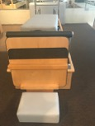

## **14” studio reformer with 1 step with tower with conversion mats, springs, roll down bar, box, jump board and moon box**

## Available September 1, 2017

## $3300

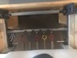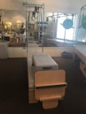

## **14” studio reformer and wall tower with revo footbar includes box, jump board, conversion mats, springs, roll down bar. Will to sell reformer or wall unit separately**

## Available September 1, 2017

## $3790

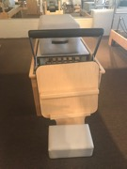



**24” studio reformer revo footbar with box, jump board and moon box**

## Available September 1, 2017

## $3300

## 

## **Clinical reformer with box, jump board and moon box.**

## Available September 1, 2017

## $3200

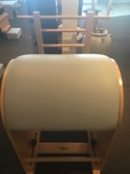

**Ladder Barrel**

## $1050